Descriptive Statistics
Excel has functions for almost all the descriptive statistics that we learned. Suppose our data are located in column A, rows 2 through 55. Then you can get descriptive statistics by the following functions --
Statistic | Excel function
Mean | =AVERAGE(A2:A55)
Median | =MEDIAN(A2:A55)
Mode | =MODE(A2:A55)
Variance | =VAR(A2:A55)
Standard deviation | =STDEV(A2:A55)
1st quartile Q1 | =QUARTILE(A2:A55,1)
3rd quartile Q3 | =QUARTILE(A2:A55,3)
The smallest value | =MIN(A2:A55)
The largest value | =MAX(A2:A55)
Interquartile range IQR | = QUARTILE(A2:A55,3)- QUARTILE(A2:A55,1)
Range | = MAX(A2:A55)- MIN(A2:A55)
Sample size (n) | =COUNT(A2:A55)

Most of these statistics can also be obtained in 1 click, from the Data Analysis Toolpak, where you choose “Descriptive Statistics” and check the box “Summary Statistics”. 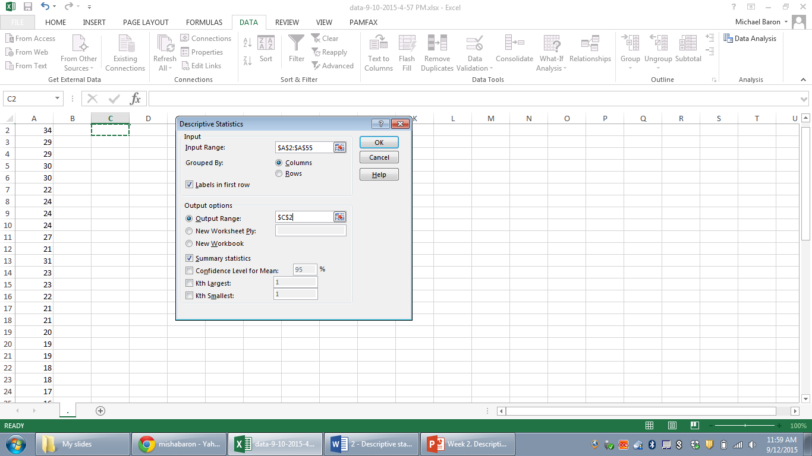
Z-scores
To obtain the entire column of Z-scores, let’s write a formula
$$Z=\frac{X-\overline{X}}{S}$$
for each observation X. We’ll write it only once and then drag over the whole data set. But when we drag through the rows, we want to preserve the sample mean and sample variance from being dragged, so we write $ in front of their row locations, as below.

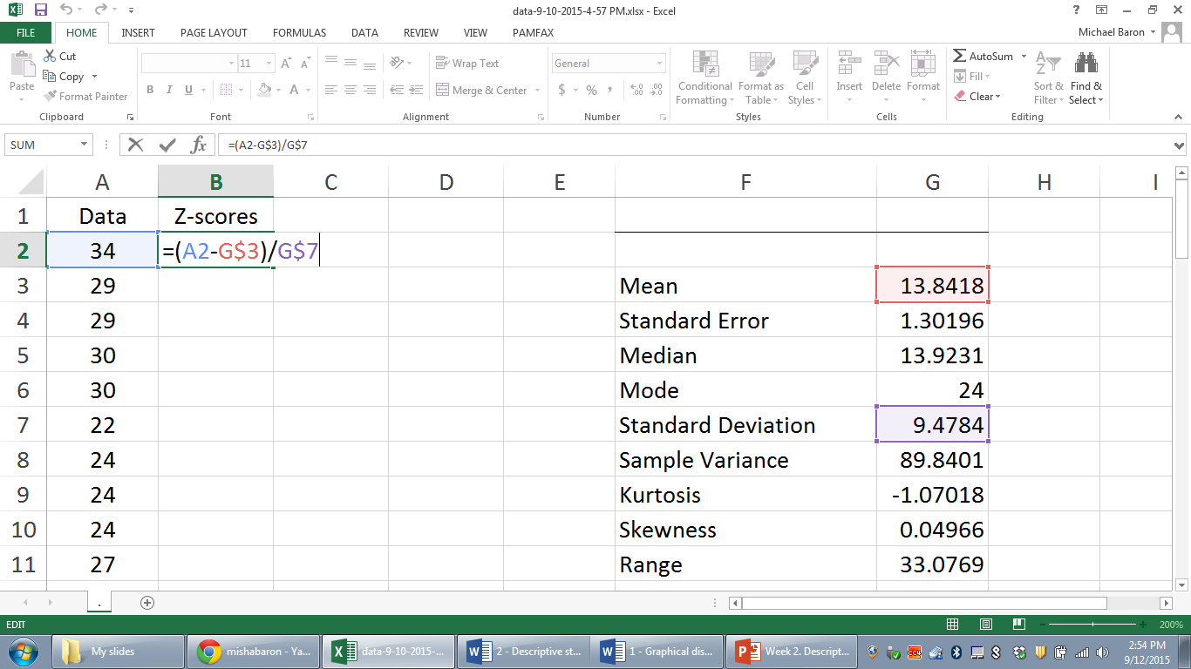

Then drag the formula down till the end of the data set. To round to the desired number of decimal digits, use the 00->0 button under the HOME tab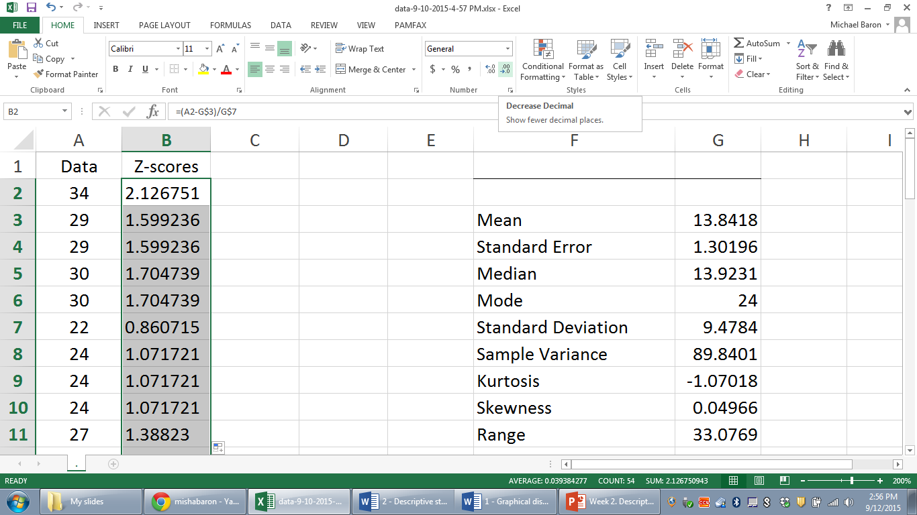
or format the highlighted cells to a “Number” specifying the desired number of decimal digits. Highlight the column, right-click, choose “Format”, and in the box, select “Number” and “decimal places”.
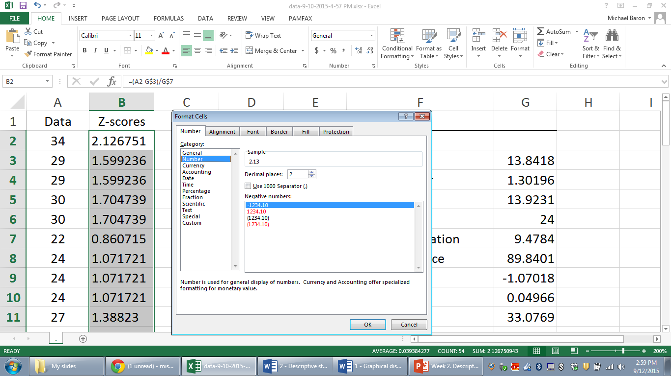

Covariance and correlation
Excel has functions =COVARIANCE.S(A2:A55,B2:B55) for the sample covariance and =CORREL(A2:A55,B2:B55) for the correlation coefficient.
Covariance and correlation can also be obtained by the respective tools in the Data Analysis Toolpak.

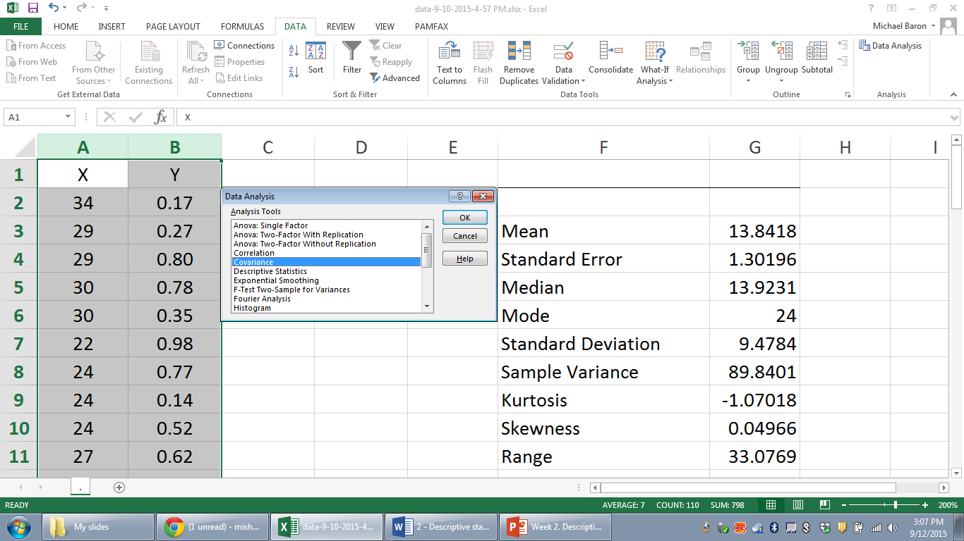

Normal probabilities and inverse problems
To compute a Normal probability, the command is
=NORM.DIST( x, mean, standard deviation, 1 )
For example, for the probability P( X < 3.5 ) for a Normal variable X with mean μ=2.2 and standard deviation σ=1.3, write =NORM.DIST( 3.5, 2.2, 1.3, 1 )
For P( X > 3.5 ), use = 1 - NORM.DIST( 3.5, 2.2, 1.3, 1 )
For P( -0.7 < X < 3.5 ), use = NORM.DIST(3.5, 2.2, 1.3, 1) - NORM.DIST(-0.7, 2.2, 1.3, 1)

To solve an inverse problem, funding a value of X given a Normal probability, the command is
=NORM.INV( probability, mean, standard deviation)
For example, to find a value x such that P( X < x ) = 0.05, use
=NORM.INV( 0.05, 2.2, 1.3 )

